BEST CHILDREN’S BIBLE APPS

Children’s Bibles
- Bible for Kids (FREE) - LifeChurch.TV , YouVersion
  - BEST FREE Children’s Bible App!!!
- The Beginner’s Bible (some is free, but totals $19.99 for everything) - HarperCollins Christian Publishing
  - BEST PAID Children’s Bible App!!!
- Bible.is KIDZ (FREE) - Faith Comes by Hearing - Listen. See. Grow.
- God’s Love: A Bible Storybook ($0.99) - Positive Action for Christ

Bible Verse Memory
- God’s Word: Hide It! (FREE) - Kingdom Media, LLC
- Verses - Bible Memory ($3.99-$6.99 depending on translation) Verses, Ltd. Co. (under iPhone apps)

Bible Trivia
- Superbook Bible Trivia Game (FREE) - The Christian Broadcasting Network
- Scripture Champion (FREE) - Kingdom Media LLC

Bible Songs
- Cubbies Bible Verse Music: Sing Along with Scripture Songs from AWANA - Kingdom Media ($7.99 for all songs)
- Bible Songs: Sing Along with Noah and other Bible Heroes for Children ($9.98 for all songs) - Kingdom Media
- GarageBand (FREE) - Apple (to play along with Christian music)

Various Bible Apps
- Got Questions? (FREE) Got Questions Ministries
- Superbook Kid’s Bible, Videos, and Games (FREE - videos can be downloaded if you are a subscriber) - The Christian Broadcasting Network
  - Best Bible Video Series for Kids!!
  - Subscribe at: https://www.cbn.com/giving/special/sbdvdclub.aspx
- Owlegories (FREE - full videos can be purchased) - Spy House, LLC

Bibles for All Ages
- ESV Study Bible ($17.99) - Crossway
  - BEST PAID Study Bible
  - Also get as an in-app purchase within the ESV Bible
- Gideons (FREE) - Faith Comes by Hearing
  - BEST FREE Audio Bible
  - Also can get through Bible.is App
  - Multiple languages to read or listen!
- YouVersion Bible (FREE) - LifeChurch.TV , YouVersion
  - #1 Rated and Downloaded Bible App

Bible Characters
- 4soils.com has a collection of Bible Characters apps (a few are free, but most have various prices with bundled prices having the most value) - Kingdom Media
  - Life of Jesus Bundle, Miracles of Jesus bundle, Parables of Jesus bundle, Bible Heroes bundle, Esther, David, Joseph, Noah, Jonah, Daniel

Bible App Icons
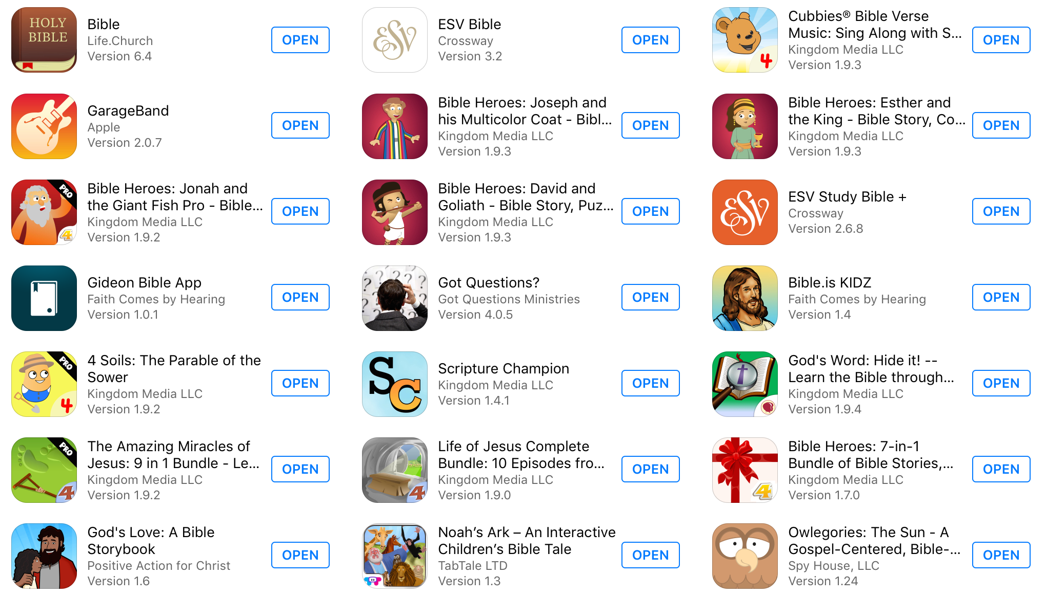
Here is what some of our favorite Children’s Bible Apps look like!

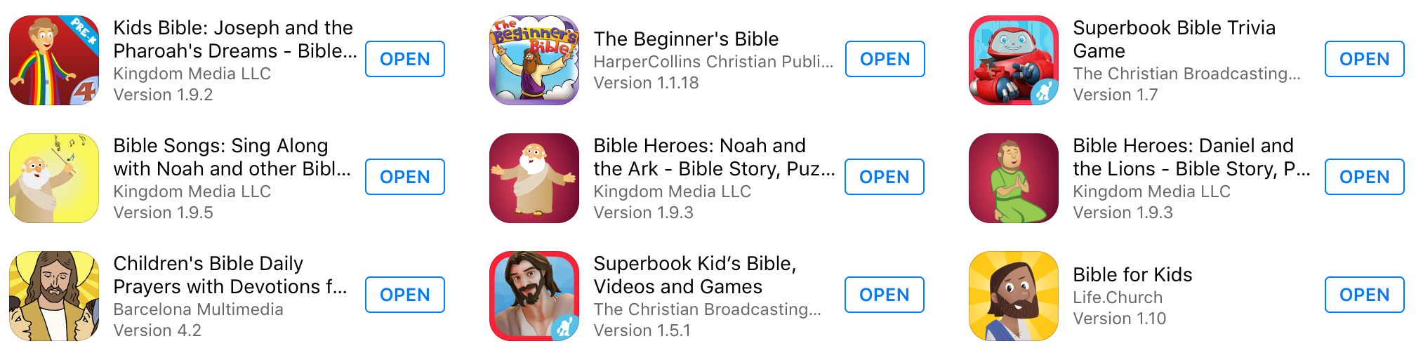

Fun Ideas on How to Use Children’s Bible Apps

- Trivia Contest: Pair up or have a group competition using a trivia app!
- Bible Verse Lookup: Have a race to see who can find a verse first!
- Character Discovery: Challenge your child to find a particular character or story on the SuperBook or another app.
- Scripture Artwork: Use an app to draw out a Scripture or color a story activity.
- Music Play Along: Use GarageBand to play instruments & sing a song or hymn.
- Find and Listen: Use Bible.is KIDZ or ESV Study Bible to play the Bible out loud.
- Bible Memory: Memorize a verse for a prize using an app to help!
- Got Questions: Find some challenging and interesting questions with Bible answers!
- Sing Along: Sing loud and proud as you place a Bible song!
- Church Happenings Exploration: Use your church’s app to explore activities.
- Language Lookup: Use the Gideons app to read a Bible verse in another language.
- Verse Connections: Use the ESV Study Bible to use notes to find corresponding verses or Bible references.

