WHAT DOES THE BIBLE
SAY ABOUT CHRISTMAS?

What is Christmas? Christmas is a Christian day of celebration (December 25th) in honor of the birth of Jesus Christ. This event is significant to Christians as it is when God the Father sent His Son Jesus Christ in the flesh (incarnation), to reveal Himself and pay the price of our sin.

What is the true meaning of Christmas? Christmas for many people is a time of family gatherings, feasting, gift-giving, and traditional memory making. While these things themselves are good, the true meaning of Christmas is focused on the birth and appearance of Jesus Christ. We must be careful not to get distracted away from Jesus in the midst of the busyness of the Christmas season.

Why did Jesus say He was born? Jesus explains that “for this purpose I was born and for this purpose I have come into the world—to bear witness to the truth. Everyone who is of the truth listens to my voice” (John 18:37 ESV). Jesus was born to show us who He is, to teach us the truth about God, to provide a way of salvation through His sinless life, sacrificial death, and powerful resurrection.

What happened on Christmas day? The day of Jesus’ birth was unusual in both its humility and majesty. Jesus was born in Bethlehem, the city of David, due to the Roman census/registration, but ultimately as a fulfillment of prophecy (Micah 5:2, Matthew 2:1-6, Luke 2:1-5). Mary gave birth to Jesus in a stable, wrapped in cloth, and laid to rest in an animal feeding trough (Luke 1:6-8). Simultaneous with Jesus’ humble birth was a magnificent and supernatural announcement by the angel of the Lord to shepherds (Luke 2:8-20) along with a multitude of angels proclaiming “Glory to God in the highest, and on earth peace among those with whom he is pleased!” (Luke 2:14 ESV)

What happened after Jesus’ birth? After Jesus was born, he went through Jewish ceremonial traditions (Luke 2:21-38). His encounter with Simeon and Anna in the temple further evidenced that he was the way of “salvation” and “redemption.” After Jesus’ birth, wise men traveled from the east, following a star, to meet and worship Jesus. At this point Jesus was residing in a house, not at a stable, and the wise men made valuable offerings of gold, frankincense and myrrh, further attesting to Jesus’ divine nature (Matthew 2:1-12). Because of the wise men’s testimony of Jesus’ fulfillment of prophecy, King Herod sought to murder Jesus by killing all of the young children in Bethlehem. Thankfully, God has warned Mary and Joseph to flee to Egypt with Jesus where they remained until the death of King Herod. Once the angel of the Lord told Joseph, they returned to Nazareth as another fulfillment of Scripture (Matthew 2:13-23, Luke 2:39-40)

Was Christmas really on December 25th? Although there are some very good historical reasons for the date of December 25th, ultimately we do not know the exact date of Jesus’ birth. The most important details about Jesus’ birth are given within the biblical accounts. Since the specific date is not shared, it is not a crucial issue of the Christian faith.

Where did all of the Christmas traditions come from? Christmas traditions and practices vary over time and culture. Some have significant connections in trying to create helpful celebrations that correlate with Christian truths, others simply arise from familial and cultural norms.

Should Christians celebrate Christmas? God warns Christians not to argue about particular days of celebration (Colossians 2:16-17), but that when making daily decisions in life we are reminded that in “whatever you do, do all to the glory of God” (1 Corinthians 10:31). We are also warned that “whatever does not proceed from faith is sin” (Romans 14:23). Although the Bible does not prescribe the regular, ceremonial remembrance of Jesus’ birth (as it does with Jesus’ death, burial and resurrection through the Lord’s Supper, 1 Corinthians 11:17-34), Christians should daily celebrate Jesus in their drawing near to Him. In addition to our daily celebration of Christ, Christians have the freedom to celebrate Jesus’ birth on Christmas as well if it builds up their faith (1 Corinthians 10:23).

“Therefore let no one pass judgment on you in questions of food and drink, or with regard to a festival or a new moon or a Sabbath. [17] These are a shadow of the things to come, but the substance belongs to Christ.” (Colossians 2:16-17 ESV)

Why did Jesus have to be both God and human? Although this concept of Jesus being simultaneously human and deity (God) is difficult to grasp, it is a biblical and essential fact. Jesus’ birth “under the law” allows the redemption, or purchase, of mankind from under the law. Only a perfect human (Jesus) would be capable and sufficient to keep and fulfill the law. Jesus’ incarnation (coming in the flesh) allows a way for humans to be adopted as God’s forever children.

Jesus’ incarnation also allowed for his shedding of blood and death because “under the law almost everything is purified with blood, and without the shedding of blood there is no forgiveness of sins.” (Hebrews 9:22) Unfortunately the blood of animals is insufficient to atone for sin (Hebrews 10:4), so only the shed blood of a perfect God-man could provide a way of salvation.

Jesus’ incarnation allowed him to sympathize with our temptations and trials, yet Jesus remained perfect, holy, and without sin (Hebrews 4:15). Jesus came in the flesh to show and teach us the Truth: that Jesus and God the Father are one (John 10:30, 14:8-11) and that Jesus is the only way of salvation (John 14:6; Acts 4:12). World religions and cults teach that salvation can be found by good works, by being “good enough.” The reality is that only Jesus, the God-man, is perfect and able to provide a way for salvation.

But when the fullness of time had come, God sent forth his Son, born of woman, born under the law, to redeem those who were under the law, so that we might receive adoption as sons. (Galatians 4:4-5)

For our sake he made him to be sin who knew no sin, so that in him we might become the righteousness of God. (2 Corinthians 5:21)

Jesus said to him, “I am the way, and the truth, and the life. No one comes to the Father except through me. (John 14:6)

And there is salvation in no one else, for there is no other name under heaven given among men by which we must be saved.” (Acts 4:12 ESV)

Why is Christmas so important? Jesus is not simply the “reason for the season,” He is the reason for life and for living. It is our hope and prayer that through this resource you discover or deepen in the love of Christ this Christmas!
What are the prophecies about Christmas? The prophecies about Jesus’ birth and life are numerous, but here are a few from a larger list:
1. Offspring of a Woman – Genesis 3:15, Luke 2:7, Revelation 12:5
2. Offspring of Abraham – Genesis 18:18, Acts 3:25, Matthew 1:1, Luke 3:34
3. Offspring of Isaac – Genesis 17:19, Matthew 1:2, Luke 3:34
4. Offspring of Jacob – Numbers 24:17, Genesis 28:14, Luke 3:34, Matthew 1:2
5. Descended from the Tribe of Judah – Genesis 49:10, Luke 3:33, Matthew 1:2-3
6. Heir to the Throne of David – Isaiah 9:7, 11:1-5, 2 Sam 7:13, Jer 23:5, Matt1:1,6, Luke 1:32-33
7. Born in Bethlehem – Micah 5:2, Matthew 2:1, Luke 2:4-7
8. Time of Birth – Daniel 9:25, Luke 2:1-2, 2:3-7
9. Born of a Virgin – Isaiah 7:14, Matthew 1:18, Luke 1:26-35
10. Slaughter of Infants – Jeremiah 31:15, Matthew 2:16-18
11. Escape into Egypt – Hosea 11:1, Matthew 2:14-15

How did Mary become pregnant with Jesus? The angel Gabriel (who has already announced the birth of John the Baptist to Zechariah and Elizabeth, Luke 1:5-24, 1:57-80) was sent by God to Nazareth to tell Mary that although she was a virgin, she would be pregnant with Jesus (Luke 1:26-56). Gabriel said “Do not be afraid, Mary, for you have found favor with God. [31] And behold, you will conceive in your womb and bear a son, and you shall call his name Jesus. [32] He will be great and will be called the Son of the Most High. And the Lord God will give to him the throne of his father David, [33] and he will reign over the house of Jacob forever, and of his kingdom there will be no end.” (Luke 1:30-33 ESV)
Mary did not understand how this could be, but Gabriel assured her that “The Holy Spirit will come upon you, and the power of the Most High will overshadow you; therefore the child to be born will be called holy—the Son of God. [36] And behold, your relative Elizabeth in her old age has also conceived a son, and this is the sixth month with her who was called barren. [37] For nothing will be impossible with God.” (Luke 1:35-37 ESV) Joseph was also told by an angel (Matthew 1:18-25) that “Joseph, son of David, do not fear to take Mary as your wife, for that which is conceived in her is from the Holy Spirit. She will bear a son, and you shall call his name Jesus, for he will save his people from their sins.” (Matthew 1:21 ESV)
Mary’s response to this amazing news? True Faith. “And Mary said, ‘Behold, I am the servant of the Lord; let it be to me according to your word.’” (Luke 1:38) Upon sharing the news with her relative Elizabeth, Mary rejoiced and sang! (Luke 1:39-56) May we all sing and celebrate in a similar manner over the birth, life, death, and resurrection of Jesus!
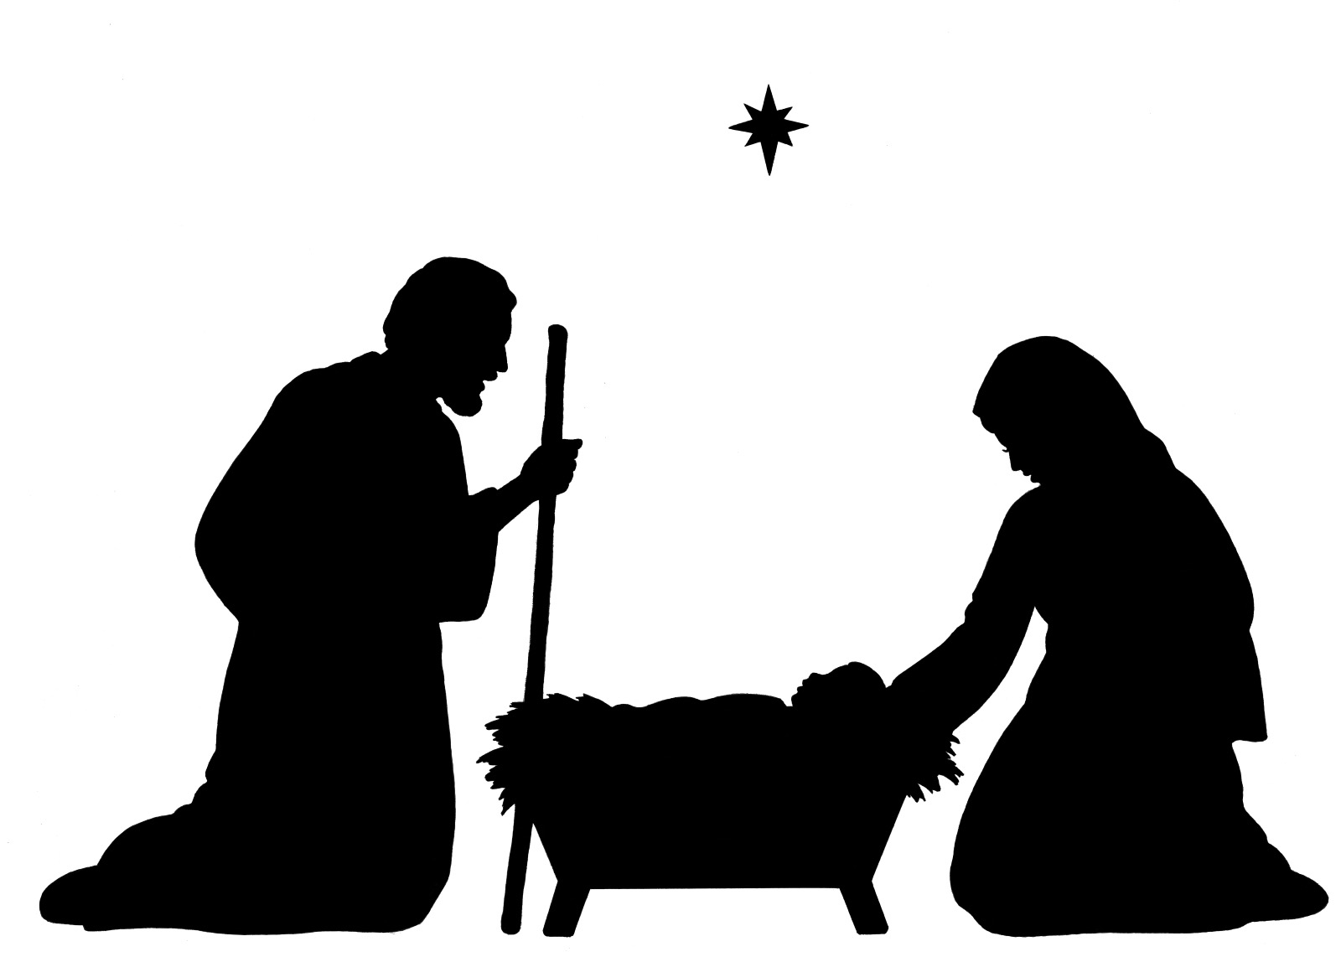
- Check out “How Can I Be Sure I am a Christian?” or “How Can I become a Christian?”
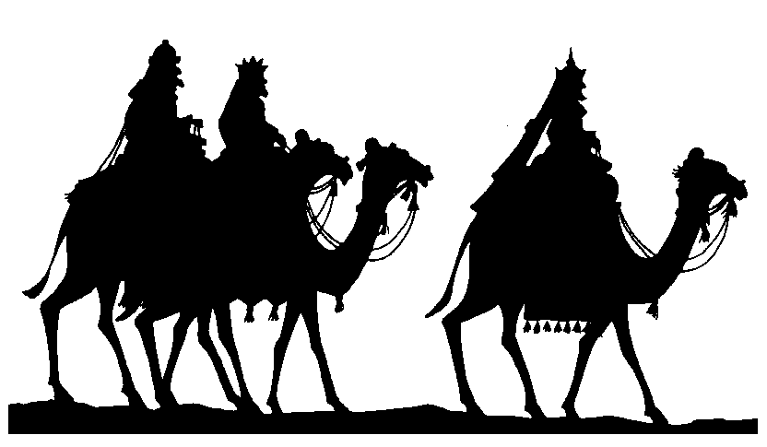
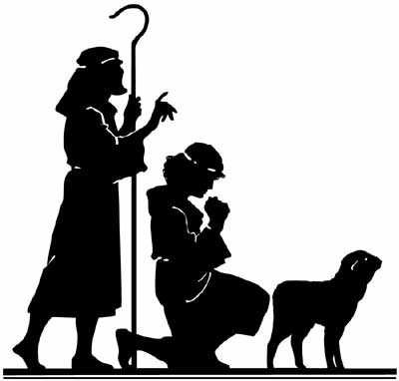
- “Evidence for Jesus”, The Case for Christmas by Lee Strobel, and gotquestions.org are also great resources!

What should I do about Christmas? BELOW are some helpful answers…

Look to Jesus and Find Joy in Christ
And an angel of the Lord appeared to them, and the glory of the Lord shone around them, and they were filled with great fear. And the angel said to them, “Fear not, for behold, I bring you good news of great joy that will be for all the people. For unto you is born this day in the city of David a Savior, who is Christ the Lord. And this will be a sign for you: you will find a baby wrapped in swaddling cloths and lying in a manger.” And suddenly there was with the angel a multitude of the heavenly host praising God and saying,“Glory to God in the highest, and on earth peace among those with whom he is pleased!” (Luke 2:9-14 ESV)

The JOY in Christ Test:

ASK YOURSELF - Is your heart cold or hardened towards God?
- Formal & routine worship. Going through the motions.
- Boredom or carelessness towards church and fellowship.
- No desire to talk about spiritual things.
- Bondage to sin: knowing a practice is sinful, but not caring enough to put an end to it.
- Out of control anger in thoughts, words, or actions.
- Selfish or critical attitude.
- Little interest or action in studying God’s Word.
- Lack of desire for prayer. Seeing prayer as a duty.
- No interest or boredom in seeing people come to know Christ
- Sacrificially giving of your time, talents, or treasures. Feeling like you “have to” instead of “get to.”
- Little desire to become more holy (sanctification). A decreasing conscience about sinfulness.
- Praying almost exclusively for yourself.
- Caring about the offense of others more than the offense of God.
- Faking it. Not being real, genuine, and open about your life.

Three Steps to JOY in Christ…
1. Repent and Draw Near to the Christ Child (James 4:8-10) Draw near to God, and he will draw near to you. Cleanse your hands, you sinners, and purify your hearts, you double-minded. [9] Be wretched and mourn and weep. Let your laughter be turned to mourning and your joy to gloom. [10] Humble yourselves before the Lord, and he will exalt you.

2. Believe in and know the Christ Child (Mark 9:22-24) “But if you can do anything, have compassion on us and help us.” [23] And Jesus said to him, “‘If you can’! All things are possible for one who believes.” [24] Immediately the father of the child cried out and said, “I believe; help my unbelief!”

3. Delight in the Christ Child(Romans 7:21-25) So I find it to be a law that when I want to do right, evil lies close at hand. [22] For I delight in the law of God, in my inner being, [23] but I see in my members another law waging war against the law of my mind and making me captive to the law of sin that dwells in my members. [24] Wretched man that I am! Who will deliver me from this body of death? [25] Thanks be to God through Jesus Christ our Lord! So then, I myself serve the law of God with my mind, but with my flesh I serve the law of sin.

Rediscover the Gift of Christmas
(Isaiah 7:14 & Isaiah 9:6-7 ESV)
He Is Immanuel – God With Us
Isaiah 7:14 therefore the Lord himself will give you a sign. Behold, the virgin shall conceive and bear a son, and shall call his name Immanuel.

Is God with you? Do you know it? Do you feel it? Are you sure?
- No? Fix it. Do Something. Stop Waiting. Seek Him.
(Deut. 4:29) you will seek the LORD your God and you will find him, if you search after him with all your heart and with all your soul.

- Yes? Live it. Be Encouraged. Draw Closer. You Are Not Alone.
(James 4:8) Draw near to God, and he will draw near to you. Cleanse your hands, you sinners, and purify your hearts, you double-minded.

He Is Your Wonderful Counselor Where do you go for advice? Answers? Solutions?
(Isaiah 9:6) For to us a child is born, to us a son is given; and the government shall be upon his shoulder, and his name shall be called Wonderful Counselor

He Is Mighty God Whose strength do you trust in? Seek Out? Act In? Daily?
(2 Corinthians 12:10) For when I am weak, then I am strong.

He Is Everlasting Father Where Is Your Focus? On Yourself? On Others? On World?
Past, Present or Future? Temporary or eternal?
(Hebrews 13:8) Jesus Christ is the same yesterday & today & forever.

He Is Prince of Peace What is your source of peace? Contentment? Stability? Hope?
(Isaiah 9:7) Of the increase of his government and of peace there will be no end, on the throne of David and over his kingdom, to establish it and to uphold it with justice and with righteousness from this time forth and forevermore. The zeal of the LORD of hosts will do this.

5 Gifts of Christ This Christmas

- Draw Near Immanuel – Read, Hear, Obey His Bible
- Go to Christ with Your Problems – Speak in Prayer
- Rely on Mighty God – Be Weak & Dependent
- Look to Everlasting Father – Turn Your Attention
- Rest in the Prince of Peace – Hope in His Plan

Let His Names Live In Your Life!
Remember that Jesus Is The Ultimate Gift
(Matthew 1 & 2, Luke 1 & 2 ESV)

7 Truths about Gifts

1. Gifts are Purposed "I am Gabriel. I stand in the presence of God, and I was sent to speak to you and to bring you this good news." Luke 1:19
2. Gifts are Planned The book of the genealogy of Jesus Christ, the son of David, the son of Abraham. Matthew 1:1, 17
3. Gifts are Promised All this took place to fulfill what the Lord had spoken by the prophet: 23 "Behold, the virgin shall conceive and bear a son, and they shall call his name Immanuel" (which means, God with us). Matt 1:22-23
4. Gifts are Surprising And Mary said to the angel, "How will this be, since I am a virgin?" 35 And the angel answered her, "The Holy Spirit will come upon you, and the power of the Most High will overshadow you; therefore the child to be born will be called holy-the Son of God." Luke 1:34-35
5. Gifts are Expressive and Relational "She will bear a son, and you shall call his name Jesus, for he will save his people from their sins." Matthew 1:21
- "he will reign over the house of Jacob forever, and of his kingdom there will be no end." Luke 1:33
6. Gifts are Loving "Greetings, O favored one, the Lord is with you!" Luke 1:28
- "For nothing will be impossible with God." Luke 1:37
7. Gifts are Free "Glory to God in the highest, and on earth peace among those with whom he is pleased!" Luke 2:14
And Mary said, "Behold, I am the servant of the Lord; let it be to me according to your word." And the angel departed from her." Luke 1:38

7 Practices with Gifts

- Anticipate the Gift They told him, "In Bethlehem of Judea, for so it is written by the prophet: 6 "'And you, O Bethlehem, in the land of Judah, are by no means least among the rulers of Judah; for from you shall come a ruler who will shepherd my people Israel.'" (Matthew 2:5-6)
- Seek the Gift Now after Jesus was born in Bethlehem of Judea in the days of Herod the king, behold, wise men from the east came to Jerusalem, 2 saying, "Where is he who has been born king of the Jews? For we saw his star when it rose and have come to worship him.” (Matthew 2:1-2)
  - After listening to the king, they went on their way. And behold, the star that they had seen when it rose went before them until it came to rest over the place where the child was. (Matthew 2:9)
- Rejoice in the Gift When they saw the star, they rejoiced exceedingly with great joy. (Matt 2:10)
- Enjoy the Gift And going into the house they saw the child with Mary his mother, and they fell down and worshiped him. (Matthew 2:11)
- Appreciate the Gift Then, opening their treasures, they offered him gifts, gold and frankincense and myrrh. (Matthew 2:11)
- Use the Gift And being warned in a dream not to return to Herod, they departed to their own country by another way. Matthew 2:12
- Share the Gift But you will receive power when the Holy Spirit has come upon you, and you will be my witnesses in Jerusalem and in all Judea and Samaria, and to the end of the earth. (Acts 1:8)

