WHY IS THE CATHOLIC BIBLE DIFFERENT THAN OTHERS?
IS THE DEUTEROCANON/
APOCRYPHA TRUSTWORTHY?

A Biblical Study of The Catechism of the Catholic Church:
Bible Answers to the Most Frequently Asked Questions about Catholic Beliefs and Practices
Full Free eBook at www.TrustworthyWord.com/catholic

- “It is clear therefore that, in the supremely wise arrangement of God, sacred Tradition, Sacred Scripture, and the Magisterium of the Church are so connected and associated that one of them cannot stand without the others. Working together each in its own way, under the action of the one Holy Spirit, they all contribute effectively to the salvation of souls.” (CCC 95)
- “The task of giving an authentic interpretation of the Word of God, whether in its written form or the form of Tradition, has been entrusted to the living, teaching office of the Church alone” (CCC 85)
- “The task of interpreting the Word of God authentically has been entrusted solely to the Magesterium of the Church, that is, to the Pope and to the bishops in communion with him.” (CCC 100)
- “It was by the apostolic Tradition that the Church discerned which writings are to be included in the list of the sacred books.” (CCC 120)
- “Tobit, Judith…1 and 2 Maccabees…Wisdom, Sirach (Ecclesiasticus)…Baruch” (CCC 120)

- READ THE APOCRYPHA FOR YOURSELF HERE: www.biblestudytools.com/rhe/

Problematic passages of The Deuterocanon to Consider:
- Tobit 6:5-7 "Then the angel said to him: Take out the entrails of this fish, and lay up his heart, and his gall, and his liver for thee: for these are necessary for useful medicines. 6 And when he had done so, he roasted the flesh thereof, and they took it with them in the way: the rest they salted as much as might serve them, till they came to Rages the city of the Medes. 7 Then Tobias asked the angel, and said to him: I beseech thee, brother Azarias, tell me what remedies are these things good for, which thou hast bid me keep of the fish? 8 And the angel, answering, said to him: If thou put a little piece of its heart upon coals, the smoke thereof driveth away all kind of devils, either from man or from woman, so that they come no more to them.”
- Tobit 6:19“burn the the liver of yonder fish, and therewith the demon shall be driven away”
- Tobit 8:2-3 “remembering what the angel had said, he took out from his wallet a piece of the fish’s liver, which he burnt on live coals. With that, the evil spirit fled; it was overtaken by the angel Raphael in the waste lands of Upper Egypt, and there held prisoner”
- Tobit 11:13-15 “Tobias took out the fish’s gall and rubbed it on his father’s eyes. He waited, maybe, for half an hour…and immediately his father’s sight was restored."
- This practice of burning the fish’s guts to drive the demonic away is identical to witchcraft. Is there any biblical justification for it?
  - Deuteronomy 18:9–14 "When you come into the land that the LORD your God is giving you, you shall not learn to follow the abominable practices of those nations. [10] There shall not be found among you anyone who burns his son or his daughter as an offering, anyone who practices divination or tells fortunes or interprets omens, or a sorcerer [11] or a charmer or a medium or a necromancer or one who inquires of the dead, [12] for whoever does these things is an abomination to the LORD. And because of these abominations the LORD your God is driving them out before you. [13] You shall be blameless before the LORD your God, [14] for these nations, which you are about to dispossess, listen to fortune-tellers and to diviners. But as for you, the LORD your God has not allowed you to do this.” (ESV)
  - Deuteronomy 32:17 "They sacrificed to demons that were no gods, to gods they had never known, to new gods that had come recently, whom your fathers had never dreaded.” (ESV)
  - 1 Corinthians 10:20 “No, I imply that what pagans sacrifice they offer to demons and not to God. I do not want you to be participants with demons.” (ESV)

- Tobit 4:11 "For alms deliver from all sin, and from death, and will not suffer the soul to go into darkness."
- Tobit 12:9 "For alms delivereth from death, and the same is that which purgeth away sins, and maketh to find mercy and life everlasting.”
- Sirach 3:3, 30 “Whoso honoureth his father maketh an atonement for his sins...Water will quench a flaming fire; and alms maketh an atonement for sin”
- The Bible speaks clearly about giving being willing and joyous, not out of motives of avoiding Hell by buying your forgiveness. Scripture is clear that forgiveness comes through faith in Jesus alone.
- Why does Sirach say honoring one’s father makes an atonement for sins? Where is that in the Bible? Doesn’t that oppose the clear teaching of Galatians 2:16 and many other passages which explain justification does not come by works, but by faith in Jesus Christ?
  - Galatians 2:16 “yet we know that a person is not justified by works of the law but through faith in Jesus Christ, so we also have believed in Christ Jesus, in order to be justified by faith in Christ and not by works of the law, because by works of the law no one will be justified.” (ESV)
- Does giving make an “atonement for sin” or “purgeth away sins”? Isn’t that contrary to 1 John 1:7 and Hebrews 9:14 & 22?
  - 1 John 1:7 “the blood of Jesus his Son cleanses us from all sin” (ESV)
  - Hebrews 9:14 “how much more will the blood of Christ, who through the eternal Spirit offered himself without blemish to God, purify our conscience from dead works to serve the living God.” (ESV)
  - Hebrews 9:22 “Indeed, under the law almost everything is purified with blood, and without the shedding of blood there is no forgiveness of sins.” (ESV)

- Tobit 3:24 “Raphael, one of the Lord’s holy angels, was sent out, bearing common deliverance to the suppliants of a single hour”
- Tobit 12:15 “I am the angel Raphael, and my place is among those seven who stand in the presence of the Lord”
- "the angel Raphael, one of the seven, who stand before the Lord" Tobit 12:15.
  - Why is Raphael/Azarias not referenced or mentioned in the Protestant canon of the Bible? Why does Tobit have so many references (almost every chapter multiple times) to angels compared to other books of the Bible?
  - Why are Michael and Gabriel the only named angels in the Protestant canon of the Bible? (Daniel 8:16, 21; 10:13,21; 12:1, Luke 1:9–26; Jude 1:9, Revelation 12:7)
  - Why does the name Raphael appear for angels in Islam, Mormonism, the Babylonian Talmud, and the book of 1 Enoch?

- Tobit 12:16-22 “the fell down trembling, face to earth. Peace be with you, the angel said…for three hours together, face to earth, they gave thanks to God”
- When Tobias and his father fall down before the angel Raphael, why does the angel not stop them from bowing down (for three hours)? Like the angel rebukes John in Revelation 22:8-9 from bowing down in front of him?
  - Revelation 22:8–9 “I, John, am the one who heard and saw these things. And when I heard and saw them, I fell down to worship at the feet of the angel who showed them to me, [9] but he said to me, “You must not do that! I am a fellow servant with you and your brothers the prophets, and with those who keep the words of this book. Worship God.” (ESV)

Sirach 12:4-7 advices, “Give to the godly man, and help not a sinner. Do well unto him that is lowly, but give not to the ungodly; hold back thy bread, and give it not unto him... give unto the good, and help not the sinner.”
Tobit 4:17 “Bestow thy meat and thy drink upon a just man’s burying, never share them with sinners.”
- Is this in line with Jesus’ commands and other biblical guidance?
- Proverbs 25:21–22 “If your enemy is hungry, give him bread to eat, and if he is thirsty, give him water to drink, [22] for you will heap burning coals on his head, and the LORD will reward you.” (ESV)
- Luke 6:27–31 “But I say to you who hear, Love your enemies, do good to those who hate you, [28] bless those who curse you, pray for those who abuse you. [29] To one who strikes you on the cheek, offer the other also, and from one who takes away your cloak do not withhold your tunic either. [30] Give to everyone who begs from you, and from one who takes away your goods do not demand them back. [31] And as you wish that others would do to you, do so to them.” (ESV)
- Romans 12:20–21 “To the contrary, “if your enemy is hungry, feed him; if he is thirsty, give him something to drink; for by so doing you will heap burning coals on his head.” [21] Do not be overcome by evil, but overcome evil with good.” (ESV)

- Wisdom 8:19,20 “For I was a witty child, and had a good spirit. Yea rather, being good, I came into a body undefiled.”
- Is anyone born without sin? Is anyone without sin? What does 1 John 1:8 say about that? How could the author of Wisdom be an exception?
  - 1 John 1:8 “If we say we have no sin, we deceive ourselves, and the truth is not in us.” (ESV)
  - Romans 3:23 “for all have sinned and fall short of the glory of God” (ESV)
  - Romans 3:10 “None is righteous, no, not one” (ESV)
  - Romans 5:12 “Therefore, just as sin came into the world through one man, and death through sin, and so death spread to all men because all sinned”
  - Romans 5:18–19 “Therefore, as one trespass led to condemnation for all men, so one act of righteousness leads to justification and life for all men. [19] For as by the one man's disobedience the many were made sinners, so by the one man's obedience the many will be made righteous.” (ESV)
  - Psalm 51:5 "Behold, I was brought forth in iniquity, and in sin did my mother conceive me.”
  - Jeremiah 17: 9 “The heart is deceitful above all things, and desperately sick; who can understand it?”

- 2 Maccabees 12:43 "And making a gathering, he sent twelve thousand drachms of silver to Jerusalem for sacrifice to be offered for the sins of the dead, thinking well and religiously concerning the resurrection.”
- 2 Maccabees 12:44-46 “For if he had not hoped that the that were slain should rise again, it would have seemed superfluous and vain to pray for the dead, 45 And because he considered that the who had fallen asleep with godliness, had great grace laid up for them. 46 It is therefore a holy and wholesome thought to pray for the dead, that they may be loosed from sins.”
- Is there anywhere in the Bible that supports the practice of offerings or prayers for the dead?

- Judith 1:5 "Now in the twelfth year of his reign, Nabuchodonosor, king of the Assyrians, who reigned in Ninive the great city, fought against Arphaxad and overcame him.”
- Why does Judith claim Nebuchadnezzar to be the king of the Assyrians when he was the king of the Babylonians?
  - “Nebuchadnezzar the king of Babylon” appears over 50 times in the Bible and even more across historical artifacts. He is never referenced as a king of Assyria anywhere other than this passage. Why does this passage get it wrong?
  - 2 Kings 24:1 “Nebuchadnezzar king of Babylon”

- Baruch 6:2, "And when you are come into Babylon, you shall be there many years, and for a long time, even to seven generations: and after that I will bring you away from thence with peace.”
- Jeremiah 25:11 says the Jews would serve in Babylon for 70 years while Baruch says seven generations. Why the difference?
  - Jeremiah 25:11 "This whole land shall become a ruin and a waste, and these nations shall serve the king of Babylon seventy years.” (ESV)
  - ESV Study Bible Note: “This is probably counted from the first exile in 605 B.C. to the first return, variously dated from 538 to 535 (2 Chron. 36:21; Ezra 1:1). However, 70 may be a rounded number, as it is elsewhere (Ps. 90:10; cf. Matt. 18:22).”

Other concerning passages:
- Sirach (Ben Sira) 40:29-30 “My son, in thy lifetime be not indigent: for it is better to die than to want. 30 The life of him that looketh toward another man's table is not to be counted a life: for he feedeth his soul with another man's meat.”
- [You should divorce if your wife does not obey you] Sirach 25:35-36 “If she walk not at thy hand, she will confound thee in the sight of thy enemies. 36 Cut her off from thy flesh, lest she always abuse thee.”
- Jeremiah took the tabernacle of the ark to a cave in the mountain Moses saw Canaan. 2 Maccabees 2:1-16
- 2 Maccabees 2:5 “And when Jeremias came thither he found a hollow cave: and he carried in thither the tabernacle, and the ark, and the altar of incense, and so stopped the door.”
- Wisdom 7:26 “For she is the brightness of eternal light, and the unspotted mirror of God's majesty, and the image of his goodness.”
- Wisdom 9:19 “For by wisdom they were healed, whosoever have pleased thee, O Lord, from the beginning.”
- “ Sirach implies our actions can bring favor upon ourselves, mitigate our sin in God’s eyes, and anticipate reciprocal responses from those we assist in their time of need" (chapters 3, 7, 12, 17, and 22)

Four Reasons the Apocrypha/Deuterocanon Should Not Be In the Bible
From: www.biblicaltraining.org/library/canon-scripture-wayne-grudem

- they do not claim for themselves the same kind of authority as the Old Testament writings;

- they were not regarded as God’s words by the Jewish people from whom they originated;
  - “When these lists are examined, we find that the earlier ones omit the Apocrypha, and that the later ones (beginning at the end of the fourth century in the West) include it. The Apocrypha began to be put on the same level as our canonical books at about the same time as many other innovations entered into the Church.” www.bible-researcher.com/canon1.html

- they were not considered to be Scripture by Jesus or the New Testament authors
  - “This fact is confirmed by the quotations of Jesus and the New Testament authors from the Old Testament. According to one count, Jesus and the New Testament authors quote various parts of the Old Testament Scriptures as divinely authoritative over 295 times, but not once do they cite any statement from the books of the Apocrypha or any other writings as having divine authority.” www.biblicaltraining.org/library/canon-scripture-wayne-grudem
  - Some of the quotes in the NT of the OT: www.bible-researcher.com/quote01.html
  - No book out of the Canon is quoted from except perhaps the word of Enoch in Jude. - “There are other Hebrew works that are mentioned in the Bible that God directed the authors to use. Some of these include the Book of the Wars of the Lord (Numbers 21:14), the Book of Samuel the Seer, the Book of Nathan the Prophet, and the Book of Gad the Seer (1 Chronicles 29:29). Also, there are the Acts of Rehoboam and the Chronicles of the Kings of Judah (1 Kings 14:29). We also know that Solomon composed more than a thousand songs (1 Kings 4:32), yet only two are preserved in the book of Psalms (72 and 127). Writing under the inspiration of the Holy Spirit in the New Testament, Paul included a quotation from the Cretan poet Epimenides (Titus 1:12) and quoted from the poets Epimenides and Aratus in his speech at Athens (Acts 17:28).” www.gotquestions.org/book-of-Jasher.html
  - NOTE: The N.T. does not quote from Esther, Ecclesiastes, Song of Solomon or Obadiah either. www.biblequery.org/Bible/BibleCanon/WhatAboutTheApocrypha.html

- they contain teachings inconsistent with the rest of the Bible.

A Brief History of the Canon of the Bible
www.bible-researcher.com/canon.html
- Peter recognized Paul’s writings as Scripture (2 Peter 3:15-16) & Some of the books of the New Testament were being circulated among the churches (Colossians 4:16; 1 Thessalonians 5:27).
- In 90 AD. the Jewish Council at Jamnia excluded from the Old Testament all but the writings Jews and Protestants accept today.
  - by A.D. 250 there was nearly universal agreement on the canon of Hebrew Scripture
- Paul considered Luke’s writings to be as authoritative as the Old Testament (1 Timothy 5:18; see also Deuteronomy 25:4 and Luke 10:7)
- Clement of Rome mentioned at least eight New Testament books (A.D. 95).
- Polycarp, a disciple of John the apostle, acknowledged 15 books (A.D. 108).
- Ignatius of Antioch acknowledged about seven NT books (A.D. 115).
- Muratorian Canon - (A.D. 180) 22 of 27 NT books www.gotquestions.org/Muratorian-Canon.html
- Later, Irenaeus mentioned 21 books (A.D. 185) & Hippolytus recognized 22 books (A.D. 170-235).
- The NT books receiving the most controversy were Hebrews, James, 2 Peter, 2 John, and 3 John
- History of when the Books of the Bible were written: www.bible-researcher.com/history1.html
- The first “canon” was the Muratorian Canon, which was compiled in AD 170
  - The Muratorian Canon included all of the New Testament books except Hebrews, James, 1 and 2 Peter, and 3 John - www.bible-researcher.com/muratorian.html
- In AD 363, the Council of Laodicea stated that only the Old Testament (along with one book of the Apocrypha) and 26 books of the New Testament (everything but Revelation) were canonical and to be read in the churches.
- Jerome on the Canon - on omitting most of the Apocrypha due to it being in Greek and not Hebrew: www.bible-researcher.com/jerome.html
- Hebrew Bible VS. Greek Septuagint VS. Latin Vulgate - www.bible-researcher.com/canon2.html
- “The first direct application of the term canon to the Scriptures seems to be in the verses of Amphilochius (cir. 380 A.D.), where the word indicates the rule by which the contents of the Bible must be determined, and thus secondarily an index of the constituent books.”
- “Among Christians there was no consensus until Jerome died and Augustine championed the Apocrypha at the Council of Carthage in 397 AD. These writings were in Bibles used by Christians for over 1,100 years. Even the King James Bible originally included it.”
- “The Council of Hippo (AD 393) & the Council of Carthage (AD 397) also affirmed the same 27 books as authoritative.”
- “Many early Christian leaders did not believe the Apocrypha scripture. Some are: Athanasius, Ambrose, Amphilochus, Athanasius, Cyril of Jerusalem, Gregory Nanzianzus, Jerome, Melito of Sardis, and Origen. The Jews Josephus and Philo also rejected it. Many others, such as Justin Martyr, wrote volumes yet never once cited it. Athanasius and Ambrose were inconsistent. Even many for it, like Augustine, believed it inspired in a lesser way.”
- First Council of Nicaea (AD 325), First Council of Constantinople (AD 381), Council of Ephesus (AD 431), Council of Chalcedon (AD 451), Second Council of Constantinople (AD 553), Third Council of Constantinople (AD 680), and Second Council of Nicaea (AD 787)
- 1380-1382 John Wycliffe and associates make first translation of the whole Bible into English
- 1388 John Purvey revises Wycliffe Bible
- 1455 Gutenberg’s Latin Bible—first from press
- 1516 Erasmus’s Greek New Testament, forerunner to the Textus Receptus used by KJV translators
- 1522 Martin Luther translated the New Testament into German (complete Bible in 1534)
- Roman Catholic Church officially added the Apocrypha / Deuterocanonicals to their Bible at the Council of Trent in AD 1546

Helpful Links for More Information

- READ THE APOCRYPHA FOR YOURSELF HERE: www.biblestudytools.com/rhe/

- The Apocrypha/Deuterocanon - www.gotquestions.org/apocrypha-deuterocanonical.html
- The books of the Apocrypha include 1 Esdras, 2 Esdras, Tobit, Judith, Wisdom of Solomon, Ecclesiasticus, Baruch, the Letter of Jeremiah, Prayer of Manasseh, 1 Maccabees, and 2 Maccabees, as well as additions to the books of Esther and Daniel. Not all of these books are included in Catholic Bibles. www.bible-researcher.com/canon2.html#reform

    - 1 & 2 Esdras - www.gotquestions.org/first-second-Esdras.html

    - The Book of Tobit - www.gotquestions.org/book-of-Tobit.html

    - Book of Judith - www.gotquestions.org/book-of-Judith.html

    - The Book of Enoch - www.gotquestions.org/book-of-Enoch.html

    - The Wisdom of Solomon - www.gotquestions.org/Wisdom-of-Solomon.html

    - Ecclesiasticus (Sirach) - www.gotquestions.org/book-of-Ecclesiasticus.html

    - Baruch - www.gotquestions.org/book-of-Baruch.html

    - The Letter of Jeremiah - www.gotquestions.org/letter-of-Jeremiah.html

    - The Prayer of Manasseh - www.gotquestions.org/Prayer-of-Manasseh.html

    - 1 & 2 Maccabees - www.gotquestions.org/first-second-Maccabees.html
      - 2 Maccabees discusses several doctrinal issues, including prayers and sacrifices for the dead, intercession of the saints, and resurrection on Judgment Day. The Catholic Church has based the doctrines of purgatory and masses for the dead on this work.

    - Additions to Esther - www.gotquestions.org/Book-Esther-God.html
      - Extra chapters - www.biblestudytools.com/rhe/additions-to-esther

    - Additions to Daniel -
      - Bel and the Dragon - www.gotquestions.org/Bel-and-the-Dragon.html
      - Prayer of Azariah (addition to Daniel 3) - www.gotquestions.org/Prayer-of-Azariah.html
      - Book of Susana - www.gotquestions.org/book-of-Susanna.html
- www.gotquestions.org/content_Bible_apocrypha.html

BOTTOM LINE: Very few early church fathers quoted or referenced the Apocrypha/Deuterocanon with any consistency. It wasn’t until after Constantine became Emperor and the Edict of Milan (313 A.D.) was issued that the Apocryphal books began to gain validity, primarily under Latin/Roman church leaders.

Here are Apocryphal books early Christian writers referred to: (reference below from: www.biblequery.org/Bible/BibleCanon/WhatAboutTheApocrypha.html )

Cr 1 Clement (of Rome) (16 pgs) 96/98 A.D.
Ba Epistle of Barnabas (13 pgs) c.100 A.D.
Ig Ignatius (21 pgs) c.110-117 A.D.
Pa Papias disciple of John (3 pgs) 110-113 A.D.
Di Didache (Teach. of 12 Disc.)(6 pgs) before 125 A.D.
Dg (anonymous) to Diognetus (6 pgs) c.130 A.D.
Po Polycarp, disciple of John (4 pgs) c.150 A.D.
Jm Justin Martyr (119 pgs) c.138-165 A.D.
He Shepherd of Hermas (47 pgs) 160 A.D.
Th Theophilus [Antioch] (33 pgs) 168-181/188 A.D.
Me Melito of Sardis (11 pgs) 170-177 A.D.
Ae Athenagoras (34 pgs) c.177 A.D.
Ir Irenaeus (264 pgs) 182-188 A.D.
Ca Clement of Alexan. (424 pgs) 193-217/220 A.D.
Te Tertullian [Rome] (854 pgs) 200-220 A.D.
Hi Hippolytus, (233 pgs) 225-235/6 A.D.
Or Origen (622 pgs) 230-254 A.D.
Nv Novatian (39 pgs) 250-257 A.D.
an Anonymous against Novatian(7 pgs) c.255 A.D.
And Treatise on Rebaptism (11 pgs)
Cp Cyprian and friends (270 pgs) 248-258 A.D.
Not shown are Bardesan (154-230) [ref. to Gen] or Julius Africanus (232-245 A.D.). [Neh,Dan by name, allude Ex]

W = Books or quotes mentioned by name or by writer
G = Mentioned as words of God + quoted
B = Mentioned as scripture or quoted + "it is written"
Q = quote of 1 or more verses. 1/2 = quote of 1/2 a verse
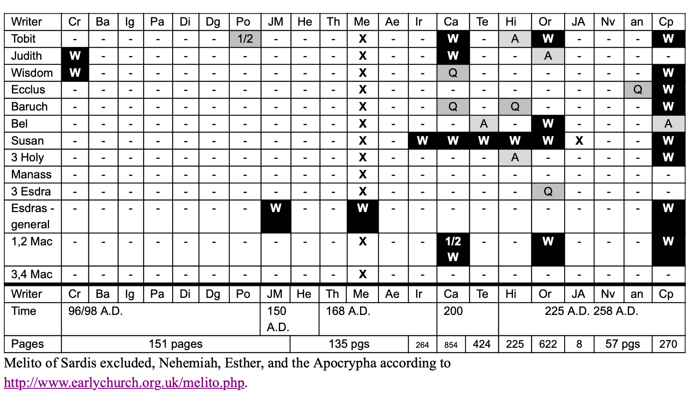
A = Allusion. - = no reference

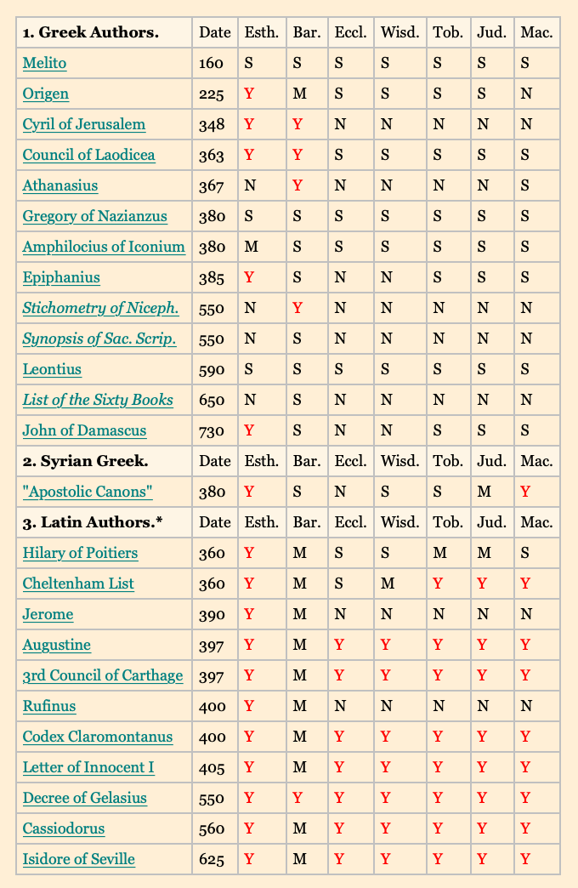
Disputed Books of the Old Testament
The table below shows which of the disputed Old Testament books are included in Christian catalogs of canonical books up to the eighth century.

Y indicates that the book is plainly listed as Holy Scripture;

N indicates that it is placed in an inferior class of books;

M indicates that the terminology of the author may be construed as a reference to the book as Holy Scripture.

An S indicates that the author does not mention the book in his catalog, which implies its rejection. See notes on the authorities below.
http://www.bible-researcher.com/canon4.html

Esth. - Esther
Bar. - Baruch
Eccl. - Ecclesiasticus
Wisd. - Wisdom of Solomon
Tob. - Tobit
Jud. - Judith
Mac. - First and Second Maccabees

Pseudepigrapha: www.gotquestions.org/pseudepigrapha.html
  - 1) they were written under false names
  - 2) They contain anachronisms and historical errors
  - 3) They contain outright heresy
    - Testament of Hezekiah, the Vision of Isaiah, the Books of Enoch, the Secrets of Enoch, the Book of Noah, the Apocalypse of Baruch (Baruch was Jeremiah’s scribe according to Jeremiah 36:4), the Rest of the Words of Baruch, the Psalter of Solomon, the Odes of Solomon, the Testaments of the Twelve Patriarchs, the Testament of Adam, the Testament of Abraham, the Testament of Job, the Apocalypse of Ezra, the Prayer of Joseph, Elijah the Prophet, Zechariah the Prophet, Zechariah: Father of John, the Itinerary of Paul, the Acts of Paul, the Apocalypse of Paul, the Itinerary of Peter, the Itinerary of Thomas, the Gospel According to Thomas, the History of James, the Apocalypse of Peter, and the Epistles of Barnabas.

