How to Respond to the Most Common Arguments for Atheism and Moral Relativism

If you haven’t seen these short films, they are worth your time (each has 3+ million views) and walk through many of these conversations below: www.fullyfreefilms.com
“Evolution vs. God” - www.EVOLUTIONvsGOD.com
“The Atheist Delusion” - www.AtheistMovie.com
“Ten of the Top Scientific Facts in the Bible"

Some touchy conversations may be best conducted with effective questions. On the topic of atheism and moral relativism, here are some of the most common arguments. The links above include many helpful bible verses and truths. Some of the questions below might be useful in keeping a conversation moving forward. Good questions help us to think through what we really believe and why we believe it. Sometimes such a line of questions helps us to see errors and truth more clearly.

Some basics tips when speaking to someone on a touchy topic:
Show Love - be kind, compassionate, gentle, and respectful - avoid anger and arrogance
Speak Truth - be convictional, clear, prepared, and honest,
Listen Well - be patient, don’t interrupt, actively listen with reflective statements
Share Jesus - ultimately anyone affirming, practicing, or identifying as LGBTQ+ does simply have a merely sexual issue, they have a sin issue, the solution to which is Jesus and the Gospel. Share the Good News of Jesus’ life, death, and resurrection and point them to salvation.
- www.trustworthyword.com/how-can-i-become-a-christian
- www.trustworthyword.com/how-can-i-be-sure-im-a-christian
- www.trustworthyword.com/evidence-for-jesus
- James 1:19–20 "Know this, my beloved brothers: let every person be quick to hear, slow to speak, slow to anger; for the anger of man does not produce the righteousness of God.”
- 1 Peter 3:15 "in your hearts honor Christ the Lord as holy, always being prepared to make a defense to anyone who asks you for a reason for the hope that is in you; yet do it with gentleness and respect”

1. The “That’s Your Truth” Argument
- other versions of this argument: “you do you, I’ll do me”, “you only live once”, “my truth, your truth”, “who are you to tell me what is right and wrong”, “I don’t agree with you”
- What do you believe about God? How did you come to that understanding? Could you be wrong?
- What if I say I don’t believe you are who you say you are. Is that not an insult against you? How serious is it if we disbelieve who God says He is? If we argue against His Word?
- How did you come to your understanding of right and wrong? How do you know you are right?
- How will you teach your children the difference between right and wrong? What if they disagree with you? Should you discipline or punish your children?
- What will you teach your children about God and eternity? Are you confident that you are correct? What if you are wrong, how would that affect your children?
- Should a government have laws? Police? Judges? Jails and prisons? Why or why not? How should they decide what is right and wrong?
- Who gets to set the rules in a classroom? A home? A sporting event? A workplace? Why?
- Who gets to set the rules in the creation? Why? What happens if those rules are ignored, rebelled against, or twisted?
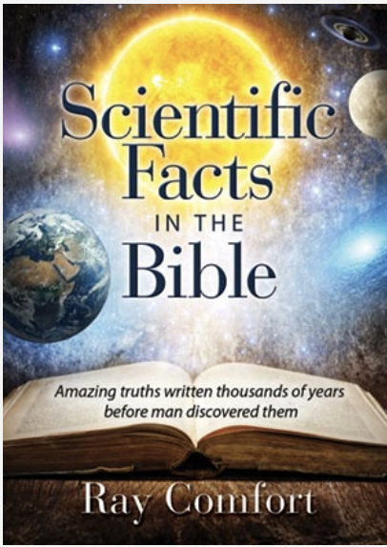
2. The “The Bible Was Written by Men” Argument
- other versions of this argument: “the Bible is full of errors”, “that’s your interpretation”, “I don’t think the Bible is literally true”, “that is just man-made religion”
- Would it make a difference if I showed you some evidence that the Bible is true?
- Have you read the Bible? You are right the Bible was written by men. When you write a letter, do you write, or does the pen? Men are God’s instruments to write the Bible. The Bible is the most accurate piece of literature in all of history…scientifically, historically, prophetically, archaeologically, and documentary or manuscript evidence. Can you find an error?
  - See www.gotquestions.org to understand some apparently difficult passages or answers to seeming contradictions.
- Which stories are true? Which stories are false? How do you know? Are you open to evidence?
- Have you seen the scientific evidence within the Bible? Check out these resources:
  - “Scientific Facts in the Bible” www.livingwaters.com/scientific-facts-in-the-bible
- Have you seen the internal, external, manuscript, archaeological, and historical evidence for Jesus?
  - “Evidence for Jesus” www.trustworthyword.com/evidence-for-jesus
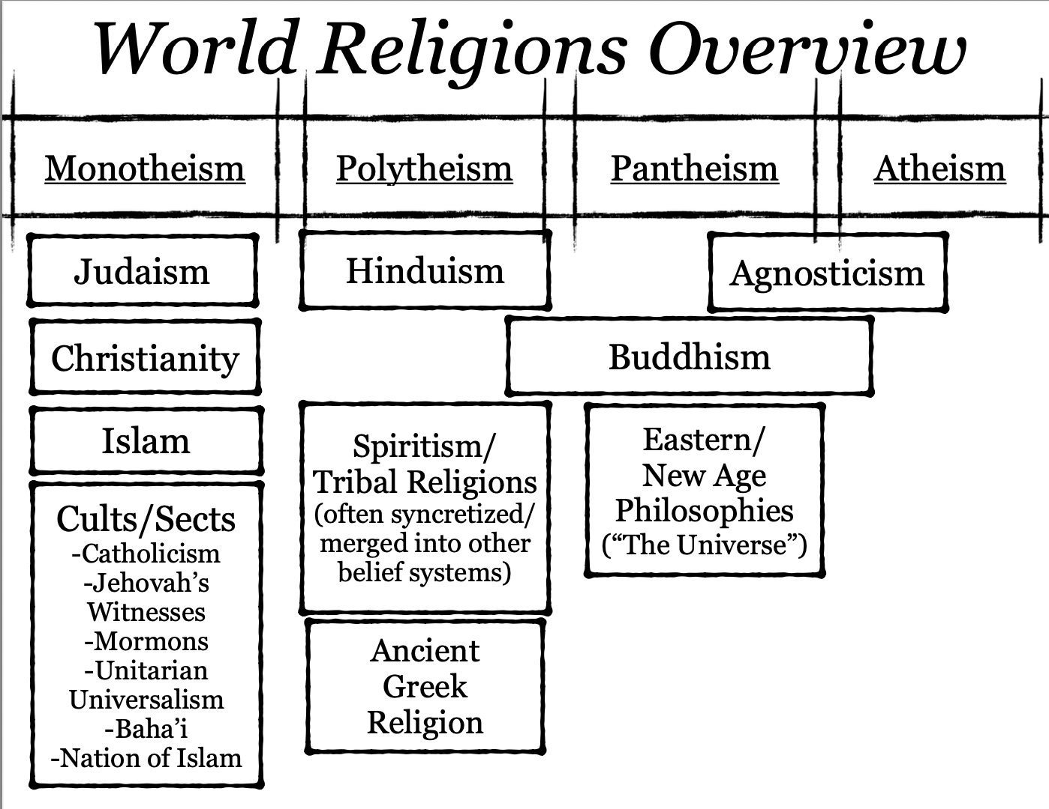
- Why don’t you like the Bible? Answer: It’s not intellectual objections ultimately, it is a moral objection ultimately. We don’t like the idea of answering to a moral authority of accountability.

3. The “All Religions Are the Same” Argument
- other versions of this argument: “as long as you are sincere in your faith”, “there are many ways to Heaven”, “Christianity is narrow minded”
- How are all religions the same? How are they different?
- Why does every religion claim to be the right/only way for salvation? Can they all be correct if they all make exclusive truth claims?
- If someone jumps out of a plane without a parachute, why would they die? Because they didn’t have a parachute? Or because they violated the law of gravity? Is ignorance an excuse? Likewise, with God’s law, is ignorance an excuse for breaking it? What are the consequences of breaking God’s law?
- Isn’t it important to figure out which world religion is correct?
- The Bible is clear that there is only one way. Jesus says in John 14:6, “I am the way and the truth and the life, no one comes to the Father except through me.” In Acts 4:12 we learn that there is only one “name under heaven given among men by which we must be saved.” I you don’t have the Son, don’t have the Father. You’re right, without Jesus, no hope for your transgression of the law. Jesus has the power to forgive sins…He openly offers that exclusive path to salvation to all who hear…would you reject Him? Put your faith in Him?
4. The “I Don’t Believe in Hell” Argument
- other versions of this argument: “God is love and forgives”, “there is nothing after death”
- What is your opinion is wrong? Are you willing to bet your life on it?
- Where is Adolf Hitler today? If no Hell, then why not do whatever you want to do?
- What does the Bible call it when you make up your own version of God? Answer: Idolatry, a violation of the 2nd commandment. Why is it so serious to have a wrong understanding of God? Why is it so concerning to misrepresent who God really is?
- Why did God send Jesus to earth to die on the cross? Read 2 Peter 3:9 “The Lord is not slow to fulfill his promise as some count slowness, but is patient toward you, not wishing that any should perish, but that all should reach repentance.” What does this mean?
- See: “What Does the Bible Say About Hell?” www.trustworthyword.com/what-does-the-bible-say-about-hell

5. The “I Am a Good Person” Argument
- other versions of this argument: “I’m not that bad”, “I don’t deserve Hell”, “I say I am sorry all the time for my sins”, “I am already saved”
- Consider civil law. If someone is guilty of a serious crime, when they come to trial, if they just say “I’m sorry” to the judge, do you think he’ll just let her go? That’s not fair. Only a corrupt or unrighteous judge would let a guilty person free without a penalty. The law has been broken. Justice demands a punishment. We can’t just say we are sorry. We can’t be “good enough” to overcome our crimes. We need Jesus to pay for the penalty for our sin.
- What does the Bible say about salvation? How has God changed you? Have you examined or tested the genuineness of your faith according to 2 Corinthians 13:5?
- God tells us to test ourselves to see if we are in the faith. Have our lives changed? Do we desire to hear God’s voice through the Bible? Are we obedient to God’s commands? Do we see the fruits of God’s Spirit (love, joy, peace, patience, kindness, goodness, faithfulness, gentleness, self-control) in our lives? (Galatians 5:22-24) Or do we see the works of the flesh in our lives (sexual immorality, impurity, sensuality, idolatry, sorcery, enmity, strife, jealousy, fits of anger, rivalries, dissensions, divisions, envy, drunkenness, orgies, and things like these)? (Galatians 5:19-21) Do we desperately seek Him in prayer? Do we see righteousness being produced by God in our lives? Are we quick to forgive? Do we love others?
- SEE “How Can I Be Sure I Am a Christian?” www.trustworthyword.com/how-can-i-be-sure-im-a-christian
- When you see a doctor and you are sick, what does he do? He assess the symptoms, shoots straight with you, and tells you about your disease and any possible cures. The Bible clearly speaks to any symptoms of ongoing, unrepentant sin in our lives. Matthew 7:21 “I never knew you.” Test yourselves.
- On moral issues…how many crimes does it take to be labeled a criminal? One murder = a murderer. One lie = liar. One theft = a thief. One lust = adulterer. It is human nature for us to trivialize sin, but sin is serious. God tells us in James 2:10 that anyone who is guilty of one sin is guilty of all sin. Are you taking your sin as serious as God wants you to?

6. The “There Is No God” Argument
- other versions of this argument: “I am an atheist”, “I trust science”
- Are you an atheist? When did you start to believe in atheism? Do you believe in evolution? Are you a strong believer?
- What is the scientific method? Answer: “the collection of data through observation and experimentation”, must be observable, repeatable, and testable
- Can you scientifically prove evolution? Can you give me some observable evidence that Darwinian evolution (not microevolution (small adaptive changes between species, speciation), but macroevolution (Darwinian evolution, large changes, between kinds/groups)) is true? What can be observed of a change of kinds? Not merely accepted by faith? So Darwinian evolution isn’t scientific?
- Look at this building. How do you know there is an architect? A builder? Look at this book. How do you know there is an author? Look at this artwork. How do you know there is an artist?
- Imagine that I told you that over billions of years molecules of wood arranged themselves into thin sheets of paper and bound themselves into a book. Then molecules of ink deposited themselves onto these pages in organized manner to communicate an important message. What would you say to me after I told you such a story? What would you call me? How then was such an infinitely more complex universe able to come into being?
- Can a book write itself? Answer: No, it’s impossible. What is DNA? Answer: It is known as the “instruction book of life.” Can DNA make itself? Could DNA happen by accident? Or must there be an intelligent source and designer?
- If the “Big Bang” theory is true, where did the first two atoms come from? How did happen to direct their paths at each other and strike each other instead of missing and passing by each other for all eternity future?
- How can you prove there is no God? What if you are wrong?
- Can you make something from nothing? Why not? Do you believe in the scientific impossibility of creating something from nothing? Where did you come from?

General Questions:
- What do you believe about the universe? Why?
- Do you ever think about your own death? Does it concern you? Do you think you are in danger?
- What do you believe about God? Are you certain about your beliefs? Are you willing to bet your eternity on it?
- Do you know what God did so you don’t have to go to Hell?
- You have to do two things to be saved, repent and believe in the Gospel. When are you going to do that?
- See: “How Can I Become a Christian?” www.trustworthyword.com/how-can-i-become-a-christian
- Do you have a good reason for putting Jesus off any longer?

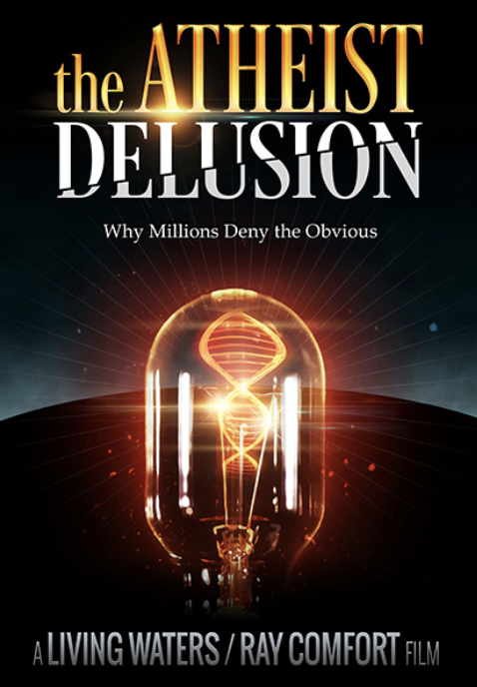
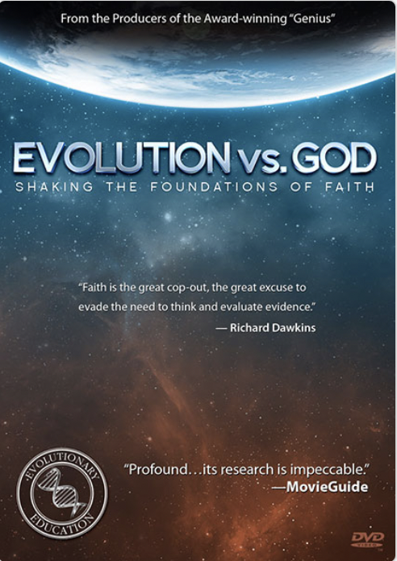
If you haven’t seen these short films, they are worth your time (each has 3+ million views) and walk through many of these conversations below: www.fullyfreefilms.com

